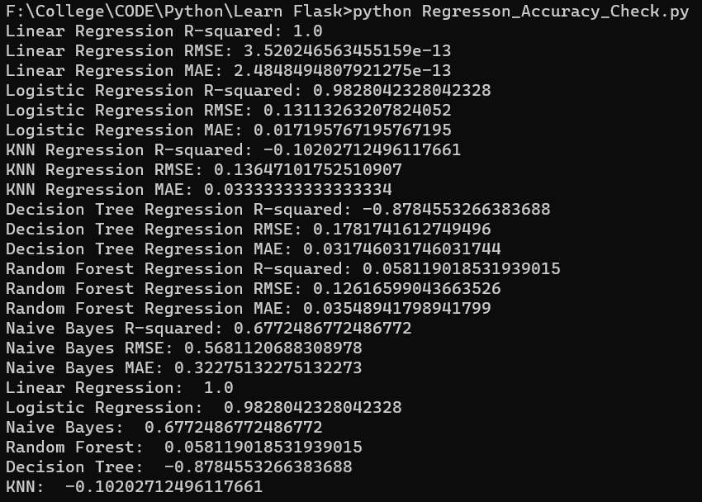
The best algorithm to use depends on the specific problem you are trying to solve and the type of data you are working with.

Based solely on the evaluation metrics provided, the linear regression model appears to perform the best with an R-squared value of 1.0 and very low RMSE and MAE values. However, it's important to keep in mind that achieving a perfect R-squared value may indicate overfitting, and the model may not generalize well to new data.

The logistic regression model also has a high R-squared value and low RMSE and MAE values, indicating good performance. However, logistic regression is typically used for classification problems, so it's unclear whether this model is appropriate for your specific problem.

The KNN and decision tree regression models have negative R-squared values, indicating poor performance. The random forest regression model has a low positive R-squared value, indicating some predictive power, but still not performing as well as the linear or logistic regression models.

The naive Bayes model has a moderate R-squared value and relatively high RMSE and MAE values, indicating some level of predictive power but potentially not as accurate as the linear or logistic regression models.

In summary, if the goal is to predict a continuous outcome variable, the linear regression model appears to be the best choice based on the given metrics. However, it's important to consider other factors such as the interpretability of the model, computational efficiency, and the specific needs of the problem at hand.
In general, a correlation coefficient of 1 indicates a perfect positive correlation, while a coefficient of -1 indicates a perfect negative correlation. A coefficient of 0 indicates no correlation. Therefore, in this case, the Linear Regression model has the best correlation result, with a correlation coefficient of 1.0, indicating a perfect positive correlation between the independent and dependent variables in the model. The Logistic Regression model also has a very high correlation coefficient of 0.9828, indicating a strong positive correlation between the independent and dependent variables in the model.
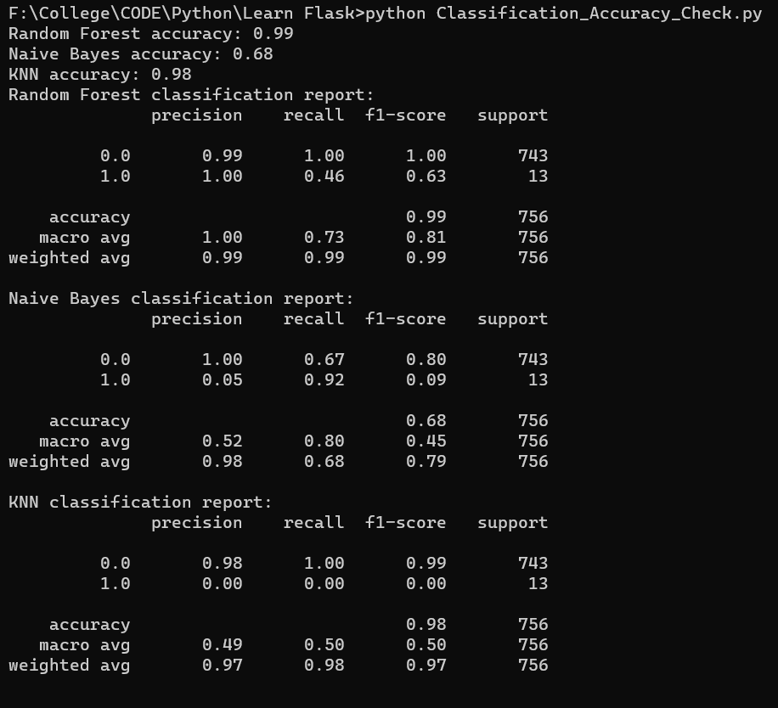

Based on the provided classification report, Random Forest seems to be the best algorithm with an accuracy of 0.99 and better precision, recall, and F1-score than the other two algorithms. Naive Bayes has the lowest accuracy (0.68) and KNN has an accuracy of 0.98 but with lower precision, recall, and F1-score for the positive class (1.0). However, the choice of the best algorithm also depends on the problem domain, dataset size, feature characteristics, and other factors, so it's always recommended to experiment with different algorithms and parameters before making a final decision.

